What is a Bash Script?
A bash script is a series of commands written in a file. These are read and executed by the bash program. The program executes line by line.
For example, you can navigate to a certain path, create a folder and spawn a process inside it using the command line.

How Do You Identify a Bash Script?

File extension of .sh.
By naming conventions, bash scripts end with a .sh. However, bash scripts can run perfectly fine without the sh extension.

Scripts start with a bash bang.
Scripts are also identified with a shebang. Shebang is a combination of bash # and bang ! followed by the bash shell path. This is the first line of the script. Shebang tells the shell to execute it via bash shell. Shebang is simply an absolute path to the bash interpreter.
Below is an example of the shebang statement.
#! /bin/bash

Execution rights
Scripts have execution rights for the user executing them.
An execution right is represented by x.

File colour
Executable scripts appear in a different colour from rest of the files and folders.

Create a file named hello_world.sh
touch hello_world.sh

Find the path to your bash shell.
which bash

Write the command.
We will echo "hello world" to the console.
Our script will look something like this:
#! /usr/bin/bash
echo "Hello World"
Edit the file hello_world.sh using a text editor of your choice and add the above lines in it.

Provide execution rights to your user.
Modify the file permissions and allow execution of the script by using the command below:
chmod u+x hello_world.sh

Run the script.
You can run the script in the following ways:
./hello_world.sh
bash hello_world.sh.

How to define variables
We can define a variable by using the syntax variable_name=value. To get the value of the variable, add $ before the variable.
#!/bin/bash
# A simple variable example
greeting=Hello
name=Tux
echo $greeting $name

Arithmetic Expressions
Below are the operators supported by bash for mathematical calculations:
Operator | Usage
+ | addition
- | subtraction
* | multiplication
/ | division
** | exponentiation
% | modulus
Let's try an example.
#!/bin/bash

var=$((3+9))
echo $var
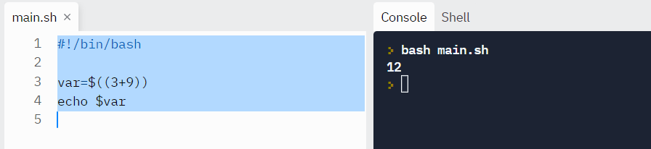

How to read user input
Sometimes you'll need to gather user input and perform relevant operations.
In bash, we can take user input using the read command.
read variable_name

Fix WSL
Fix The Operation Could Not Be Started Because a Required Feature Is Not Installed: WSL
Common commands:
- systemctl start service_name: Starts a specified service.
- systemctl stop service_name: Stops a running service.
- systemctl restart service_name: Restarts a service.
- systemctl status service_name: Shows the status of a service, including its operational state and log messages.
- systemctl enable service_name: Configures a service to start automatically at system startup.
- systemctl disable service_name: Prevents a service from starting automatically at boot.
- systemctl is-enabled service_name: Checks if a service is configured to start at boot.
When to use it:
- System administration: For managing server services, configurations, and system startup behavior.
- Troubleshooting: To check the status of a service and view logs when it's not functioning correctly.
- System maintenance: To manage the state of system units and ensure services are running as intended.

2>/dev/null Most if not all programs have stdout (output to the screen unless you do >somefile to write the output to a file) and stderr which I believe by default writes to the same place as stdout. If you want to not print the errors at all, you add 2>/dev/null to send all stderr output to a trash can basically. If you wanted to log errors for example in a separate file you can do 2>somefile.
https://hemantjain.medium.com/linux-question-what-is-dev-null-2-1-82d75a156b5c#:~:text=So%202%3E%261%20simply%20says,not%20to%20shout%20while%20executing.

